What is TDD?

Test-driven development (TDD) is an evolutionary approach to development which combines test-first development where you write a test before you write just enough production code to fulfill that test and refactoring.

What is the primary goal of TDD?

One view is the goal of TDD is specification and not validation. In other words, it’s one way to think through your requirements or design before your write your functional code (implying that TDD is both an important agile requirements and agile design technique). Another view is that TDD is a programming technique.
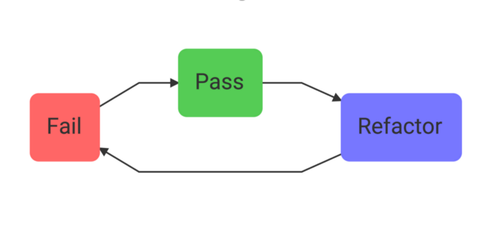

- Before you write implementation code, write some code that proves that the implementation works or fails. Watch the test fail before moving to the next step (this is how we know that a passing test is not a false positive — how we test our tests).

- Write the implementation code and watch the test pass.

- Refactor if needed. You should feel confident refactoring your code now that you have a test to tell you if you’ve broken something.

Why TDD?

- A significant advantage of TDD is that it enables you to take small steps when writing software.

- For example, assume you add some new functional code, compile, and test it. Chances are pretty good that your tests will be broken by defects that exist in the new code. It is much easier to find, and then fix, those defects if you've written two new lines of code than two thousand.

- The implication is that the faster your compiler and regression test suite, the more attractive it is to proceed in smaller and smaller steps.

- TDD is for improved test coverage which leads fewer bugs in production.

Where to use TDD?

- Test-driven development (TDD) is a development technique where you must first write a test that fails before you write new functional code.

- TDD is being quickly adopted by agile software developers for development of application source code and is even being adopted by Agile DBAs for database development.

When to do TDD?

- TDD lends itself really well to when you have a pure logic function that you need to write.

- When the work you need to do has a clearly defined set of expected inputs and outputs, it's a great signal that you should use TDD to build out your tests and code.

- Anytime you recognize that your code needs to make decisions or calculations, you should break it out into its own method and use TDD to write that method.

- When coordinating different modules or integrating with systems you don't control, TDD can help find the correct seams between layers. To do this, start with the entry point to the system and try to integrate with all of the dependencies.

When not to do TDD?

- If you have an existing codebase that doesn't have any unit tests at all, it can be difficult to start doing TDD.

- It also might not be worth it to use TDD on something that's already working. In these situations, when you make changes, you should definitely start by creating some unit tests around the existing system.

- As you build a suite of tests, you can look for opportunities to start following TDD. Don't try to rewrite or start from scratch something that's already working just so you can use TDD.

How to do TDD?

The following sequence shows the steps to do test driven development

1. Add a test
In test-driven development, each new feature begins with writing a test. Write a test that defines a function or improvements of a function, which should be very succinct. To write a test, the developer must clearly understand the feature's specification and requirements.
2. Run all tests and see if the new test fails
This validates that the test harness is working correctly, shows that the new test does not pass without requiring new code because the required behavior already exists, and it rules out the possibility that the new test is flawed and will always pass. The new test should fail for the expected reason. This step increases the developer's confidence in the new test.
3. Write the code
This step is to write some code that causes the test to pass. The new code written at this stage is not perfect and may, for example, pass the test in an inelegant way. That is acceptable because it will be improved and honed in Step

4. Run tests
If all test cases now pass, the programmer can be confident that the new code meets the test requirements, and does not break or degrade any existing features. If they do not, the new code must be adjusted until they do.
5. Refactor code
The growing code base must be cleaned up regularly during test-driven development. New code can be moved from where it was convenient for passing a test to where it more logically belongs. Duplication must be removed. Object, class, module, variable and method names should clearly represent their current purpose and use, as extra functionality is added. By continually re-running the test cases throughout each refactoring phase, the developer can be confident that process is not altering any existing functionality.
6. Repeat
Starting with another new test, the cycle is then repeated to push forward the functionality. If new code does not rapidly satisfy a new test, or other tests fail unexpectedly, the programmer should undo or revert in preference to excessive debugging. Continuous integration helps by providing revertible checkpoints.

